Algebra II
Teacher: Ms. Burchfield
Contacting Ms. Burchfield
e-mail: burchfieldj@dcpsmd.org
classroom: E17B
phone: 410-228-4747 ext. 1726

Ms. Burchfield can frequently be found in her classroom at lunch and after school. However, the safest thing to do if you need to meet with Ms. Burchfield is to e-mail her to set up an appointment.
Algebra II
Welcome to Algebra II! Algebra II is a full-year course designed to develop students' problem solving and reasoning skills, to build solid connections between various applications and models, and to communicate complex ideas effectively to others. Over half of all college majors require working with models and numerical information at the university level, making this course the foundation of many future opportunities.
The course will focus on the Maryland Standards for Mathematical Practice.
1. Make sense of problems and persevere in solving them.
2. Reason abstractly and quantitatively
3. Construct viable arguments and critique reasoning of others.
4. Model with mathematics.
5. Use appropriate tools strategically.
6. Attend to precision.
7. Look for and make use of structure.
8. Look for and express regularity in repeated reasoning.

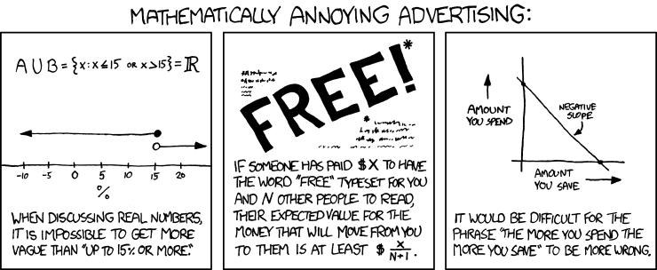
http://xkcd.com/870/

Topics of Study

Unit 1: Quadratic Relations and Functions
Unit 2: Polynomials
Unit 3: Rational Equations and Functions
Unit 4: Radical Equations and Functions
Unit 5: Exponential and Logarithmic Equations and Functions
Unit 6: Trigonometry

Resources and Materials

Textbook: McDougal Littell Algebra 2; Discovery Education Techbook, Algebra II

Weebly: all handouts, including assignments, are provided both physically and electronically on our course Weebly page. The Materials page contains links to study resources. The Homework page displays deadlines and upcoming quizzes and tests. You should check this webpage if you have questions and if you missed class.

Materials: you should bring the following materials to class every day unless otherwise specified:
- A TI-84 calculator is provided for class as part of a class set. Do not forget your calculator number!
- Pencils and erasers.
- Notebook (see “Course Notebook”)

Grading Policy
All grades at CSD are weighted according to the following categories:

Per Quarter:
- Formative (40%): You will be assigned frequent problem sets and activities to practice your skills.
- Summative (60%): The posters and papers you create in groups; tests and quizzes; and any other assessment that ends a unit are summative assessments.
Per Semester:
- First Quarter (45%)
- Second Quarter (45%)
- Final Exam (10%): A cumulative exam is given at the end of each term.
A | B | C | D | E
90-100% | 80-89% | 70-79% | 60-69% | Below 60%

The gradebook is located in PowerTeacher. Late assignments are indicated by a “zero.” If an assignment is late due to absence, a comment will accompany the score with the modified due date. A “.01” in the gradebook indicates an assignment for which the student was present but did not submit work. This will be accompanied by the comment “present but no work.” Students may make up .01 assignments for partial credit until the summative is given.

Course Notebook
You are expected to keep your notes and daily work in the composition book provided at the beginning of the year. This will be checked regularly and scored according to the rubric provided. Keep your work organized, and show every step!

Absences and Late Work
If you are absent for any reason, check Weebly for assignments and contact Ms. Burchfield to let her know why you are absent and to make a plan to make up the work you missed. You will have an additional day to turn in homework that is due the day after your absence. Late work will be penalized by 10% unless an extension was granted.

