Algebra II Notes 10/12 or 10/15/18
Rationalizing Complex Fractions
Warm-up: Find $\sqrt{4}∙\sqrt{4}$
Today, we’ll discuss rationalizing radical expressions. Just like with fractions excluding any radicals, we want to write fractions with radicals and imaginary numbers in the simplest, most consistent possible way. That means that we will NOT leave a radical or an imaginary number in the denominator.
Examples: rationalize:
$$\frac{3\sqrt{7}}{\sqrt{3}}$$
Work: to cancel the square root, we must multiply the denominator by itself. Anything we do to the denominator, we must also do to the numerator!
$$\frac{3\sqrt{7}}{\sqrt{3}}∙\frac{\sqrt{3}}{\sqrt{3}}= \frac{3\sqrt{21}}{3}=\sqrt{21}$$
Any time you multiply with square roots, you may multiply together numbers that are both under the root, or both outside the root, but do not multiply numbers outside times numbers under the root!
Don’t forget to simplify if possible as your last step. 21 has no twins, but 3 ÷ 3 = 1.
Next, we’ll rationalize:
$$\frac{3}{i}$$
Since $i=\sqrt{-1}$, we will treat it as a square root. $i^{2}=-1$. Any time you see i², replace it with -1.
$$\frac{3}{i}∙\frac{i}{i}= \frac{3i}{-1}= -3i$$

Sometimes you’ll need to rationalize a denominator that is a complex number (in the form a + bi):
$$\frac{3}{2+i}$$
This is tricky! Since we distribute when we multiply, we must choose carefully. We will always multiply by the conjugate: a – bi (or in this case, 2 – i)
$$\frac{3}{2+i}∙\frac{2-i}{2-i}=\frac{3(2-i)}{(2+i)(2-i)}$$
Don’t forget to distribute/FOIL/use the rainbow method!
$$\frac{3(2-i)}{(2+i)(2-i)}=\frac{6-3i}{4+2i-2i-i^{2}}= \frac{6-3i}{4-i^{2}}=\frac{6-3i}{4-(-1)}=\frac{6-3i}{5}$$

Classwork (homework if not finished): Complete #1-10. 11 and 12 are challenge problems.

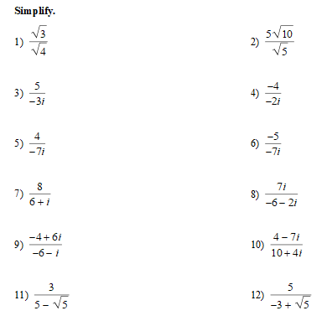

Need another reference? Try:
https://www.khanacademy.org/math/precalculus/imaginary-and-complex-numbers/complex-conjugates-and-dividing-complex-numbers/a/dividing-complex-numbers-review

