Algebra II Practice Name: ________________
Introduction to Complex Numbers
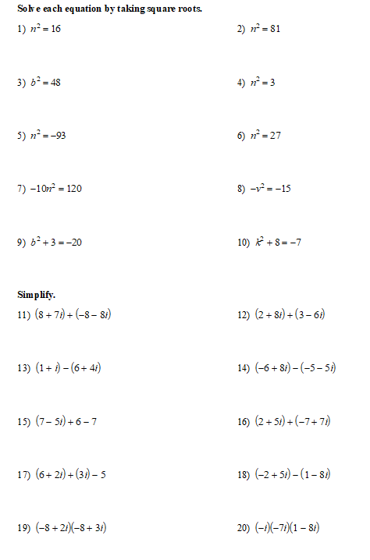

Selected Answers:

