Algebra II Classwork/Homework Name: _______________
Operations with Polynomials and Classifying Polynomials Date: ________________
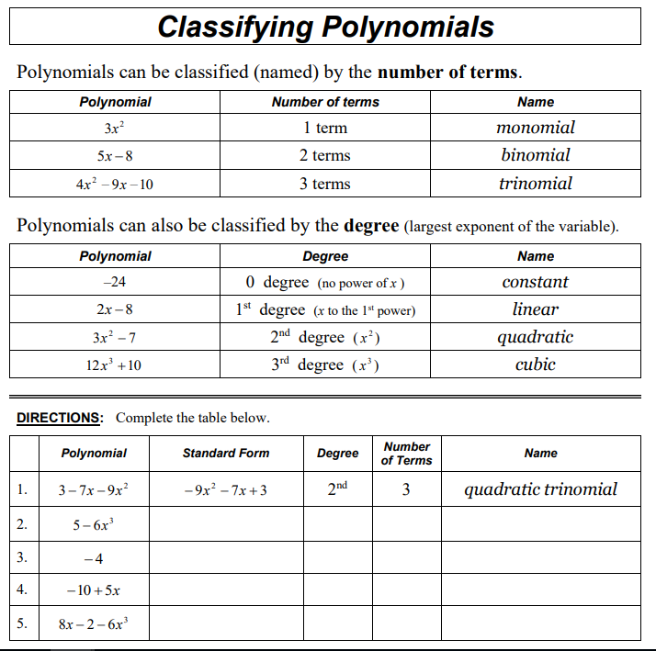
Examples of polynomial multiplication:
Example 1:
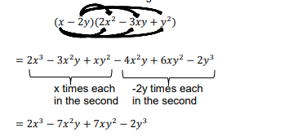
Example 2:
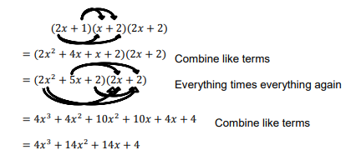

Classwork/homework: Perform the following operations. Classify the resultant polynomial by degree and number of terms.
13. (8x² + 1) + (3x² – 2)
15. (x² – 6x + 5) – (x² + x – 2)
23. (10x³ – 4x² + 3x) – (x³ – x² + 1)
24. (50x – 3) + (8x³ + 7x² + x + 4)
27. x(x² + 6x – 7)
28. 10x²(x – 5)
33. (x + 3) (x² – 4x + 9)
34. (x + 8)(x² – 7x – 3)
43. (x² + x + 4)(2x² – x + 1)
44. (x² – x – 3)(x² + 4x + 2)
45. (x + 9)(x – 2)(x – 7)
46. (x + 3)(x – 4)(x – 5)

