Algebra II Classwork Name: _________________________
Operations with Complex Numbers
Today you’ll practice operations with complex numbers. In almost all cases the rules for working with “i” are the same as the rules for working with “x:”
- When adding/subtracting, combine like terms.
- When multiplying, distribute.
- When dividing, create and simplify a fraction.
There are two important additions to these rules when working with i:
- Whenever you see i², replace it with -1.
- A fraction is not simplified completely if there is an “i” in the denominator.
Instructions for today:
- Delegate one member of your table to retrieve Algebra 2 textbooks from the shelves by the door for each student at the table.
- Turn to page 273 in the book.
- In your notebook, COPY examples 3, 4 and 5. If you have forgotten your notebook, work on a separate sheet of paper.
- Turn to page 277. TRY #17-20, 38-43, 47-51, and 58-62 into your notebook. Do as many problems as you can as classwork. (You will get ONE bonus quiz point for every FIVE correct problems you show, with work.)
- Homework: do EVEN problems on the attached worksheet. Ms. Burchfield will check these—and the examples you copied—the next time she sees you!
- Return the textbook to the shelf at the end of class.

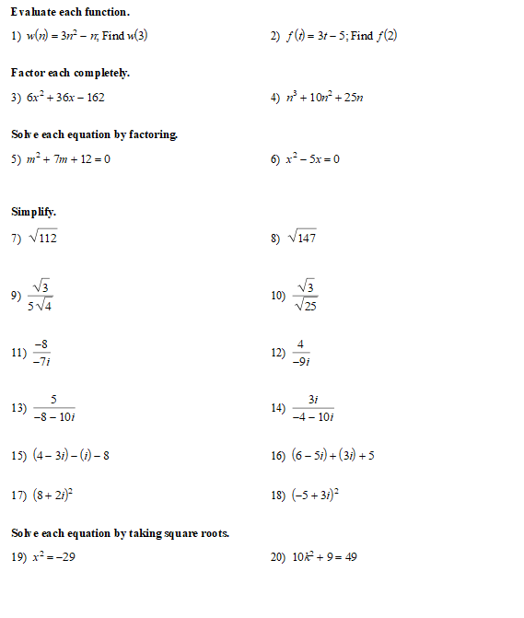
Selected answers:

