Algebra II Notes 10/10-11/18
Multiplying Complex Numbers
Warm-up: Simplify:
(x + 1)(2x – 3) (1 + i) – (-3 + 2i) (1 + i)(-3 + 2i)

- What is i?

- What is i²?

- What is (x + 1)²?

HOMEWORK REVIEW: Make a poster of the problem taped to your desk. Show your work!

Today we will practice multiplying complex numbers. Remember to FOIL/distribute/use the rainbow! The only trick will be simplifying powers of i. Go back to the warm up and correct the third problem.
- More problems (homework if not finished):

https://www.khanacademy.org/math/algebra2/introduction-to-complex-numbers-algebra-2/multiplying-complex-numbers-algebra-2/a/multiplying-complex-numbers
Algebra II Notes 10/12 or 10/15/18
Rationalizing Fractions
Warm-up: Simplify $\frac{4}{6}$ Find $\sqrt{4}∙\sqrt{4}$
Homework review: List questions you still have on the homework.
Today, we’ll discuss rationalizing radical expressions. Just like with fractions excluding any radicals, we want to write fractions with radicals and imaginary numbers in the simplest, most consistent possible way. That means that we will NOT leave a radical or an imaginary number in the denominator.
- How can we change the denominator of a fraction without changing the value of the fraction?
- How can we cancel a square root?
- How can we make a real number from i?
Try it: rationalize:
- $\frac{3}{\sqrt{2}}$

- $\frac{3\sqrt{6}}{\sqrt{3}}$

- $\frac{3}{i}$

- Classwork (homework if not finished):
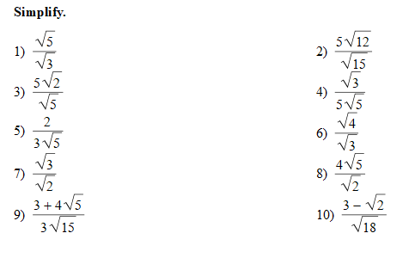
https://www.khanacademy.org/math/algebra-home/alg-exp-and-log/miscellaneous-radicals/v/how-to-rationalize-a-denominator

