Algebra II Classwork/Homework Name: _________________________
Long Division Review Date: __________________________

Long Division: Examples
Example 1: 3640 divided by 15
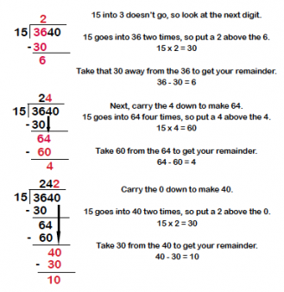
Example 2: 1598 divided by 34
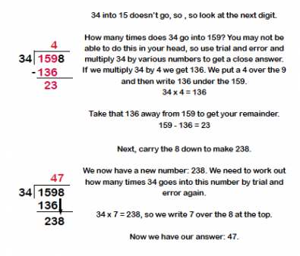

On Reverse: Long Division: Practice (Complete as Homework!)
