Algebra II Notes 10/4-5/18
Solving Quadratic Equations with Square Roots – Imaginary Numbers
Warm-up: Solve the following equations:
x² = 36 x² = -1
- What techniques did you use to solve these problems?
- What is the inverse of a square—that is, what will undo a square?
Something different: In Algebra II, we often simplify radicals (square roots). This is to say, we will take out any factors that are squared, and only leave unsquared factors under the radical. Here’s an example. We’ll find a factor tree of 72, using only prime numbers:

- How could we simplify $\sqrt{72},$ given that $\sqrt{72}=\sqrt{{2^{2}∙3}^{2}∙2}$ ?

- Try it: simplify $\sqrt{75}$ and $\sqrt{12}$

Something even weirder: In Algebra II, we will work with “imaginary numbers.” Mathematicians have created a placeholder to indicate the square root of -1:
NB i stands for “imaginary;” imaginary numbers are useful in physics and chemistry as future work often turns them back into real numbers!

- What is a common factor of every negative number?
- Try it: simplify $\sqrt{-5}$ and $\sqrt{-12}$

- More problems (homework if not finished):
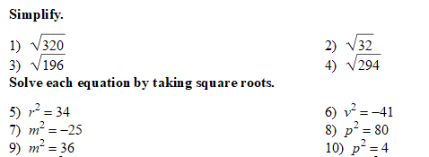

https://www.khanacademy.org/math/algebra2/introduction-to-complex-numbers-algebra-2/the-imaginary-numbers-algebra-2/v/imaginary-roots-of-negative-numbers

Algebra II Notes 10/5 or 8/18
Adding and Subtracting Complex Numbers
Warm-up: Simplify $\sqrt{-52}$
Homework review: List questions you still have on the homework.
Today, we’ll discuss complex numbers. Sometimes in solving quadratic equations, you’ll find an answer that is the sum of an imaginary number AND a real number. Here’s an example:
- (x + 3)² = -1

Complex numbers are generally written in the form a + bi, where a and b are real numbers. Quick check:
- What is 3 + 4?
- What is 3i + 4i?
- Can you simplify 3 + 4i?
- More problems (homework if not finished in class):
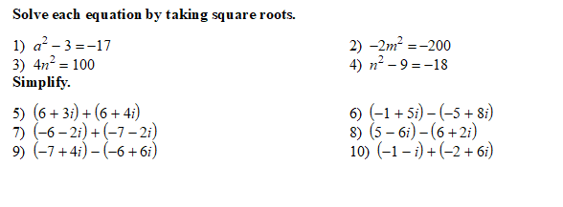

https://www.khanacademy.org/math/algebra2/introduction-to-complex-numbers-algebra-2/adding-and-subtracting-complex-numbers-algebra-2/v/adding-complex-numbers

