Algebra II Notes/Classwork Name: _________________________
Introduction to Synthetic Division of Polynomials Date: __________________________
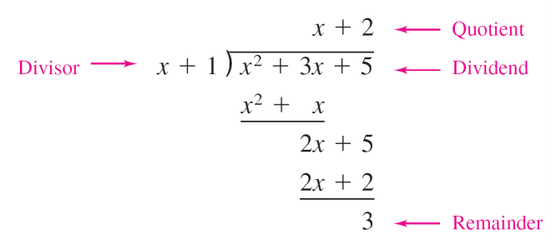
Warm-up: Solve$(2x^{3}-5x^{2}-x+3)÷(x+3)$ using long division.

Synthetic Division of Polynomials: Examples
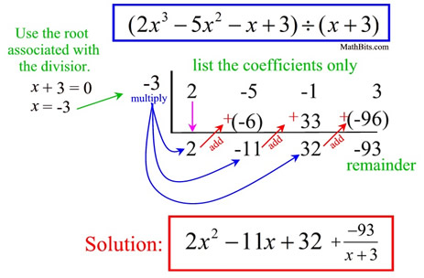
Example 1: $({3x}^{3}+{4x}^{2}-2x-1)÷(x+4)$

Example 2: $({2x}^{4}+{4x}^{2}-1)÷(x-1)$

Synthetic division ONLY works if:

Classwork/Homework: Complete the following problems before our next class.
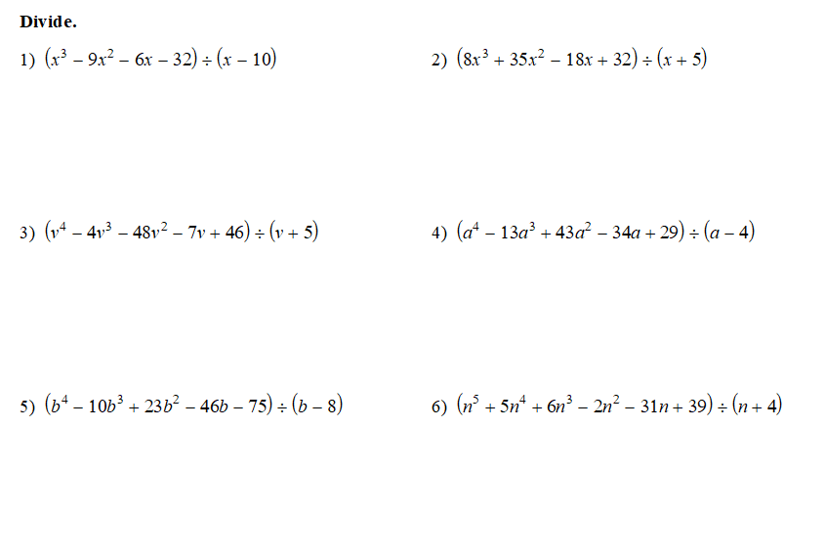

Check your work: your remainders should be 8, -3, 6, 5, 5, 3, -8.

https://www.khanacademy.org/math/algebra2/arithmetic-with-polynomials/synthetic-division-of-polynomials/v/synthetic-division
https://mathbitsnotebook.com/Algebra2/Polynomials/POPolySynDivide.html

