Algebra II Notes/Classwork Name: _________________________
Introduction to Long Division of Polynomials Date: __________________________
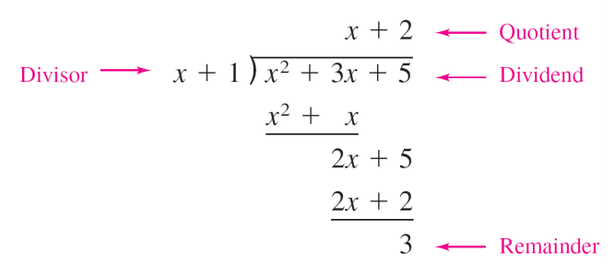
Warm-up: Solve$209÷7$ using long division. (Hint: look at your homework!) Label the remainder. How could you write the quotient in fraction form?

Long Division of Polynomials: Examples
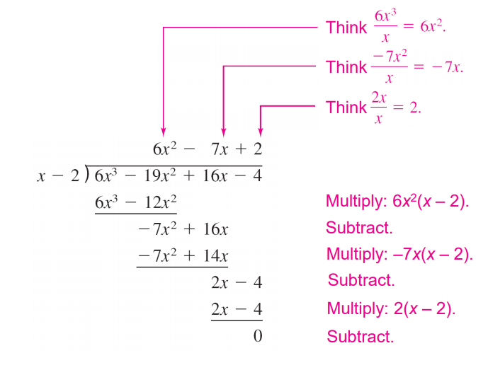
Example 1: $(x^{2}-3x+2)÷(x-2)$
Take notes on the video to solve this problem. Label the remainder.

Example 2: $({5x}^{2}+3x-14)÷(x-1)$
We will do this as a class. You may be called to do a step on the board! Write down what your classmates do.

Classwork/Homework: Complete the following problems before our next class.
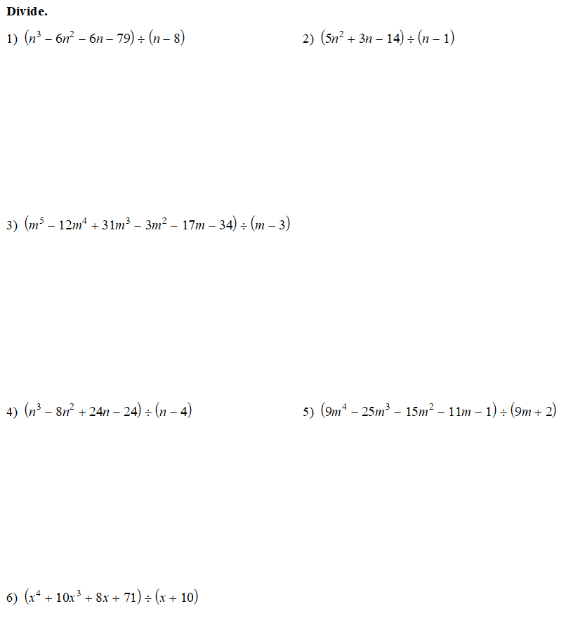

Check your work: your remainders should be 1, -6, -4, 8, 1 -9.

https://www.khanacademy.org/math/algebra2/arithmetic-with-polynomials/long-division-of-polynomials/v/dividing-polynomials-1
https://academics.utep.edu/Portals/1788/CALCULUS%20MATERIAL/2_3%20POLYNOMIAL%20AND%20SYNTHETIC%20DIVISION.pdf

