Algebra II Notes/Homework Name: _________________
Intercepts and Extrema on Polynomial Graphs Date: __________________
Warm-up: Write y = (x + 6)(x + 5) in standard form.

Some vocabulary:
- x-intercept: the x-coordinate of the point where a function intersects the x-axis. Given an equation for the function, this is the value of x when y = 0.
- zero: the value of the independent variable (usually x) when the dependent variable (usually y) is 0.
- root: the value of the independent variable that causes a polynomial to evaluate to zero.
- y-intercept: the y-coordinate of the point where a function intersects the y-axis. Given an equation for the function, this is the value of y when x = 0.
- local (relative) minimum: the lowest value of the dependent variable, y, in a neighborhood of a graph.
- local (relative) maximum: the highest value of the dependent variable, y, in a neighborhood of a graph.
- absolute minimum: the lowest value of the dependent variable, y, for which a function is defined.
- absolute maximum: the highest value of the dependent variable, y, for which a function is defined.
- extremum: any minimum or maximum.
Example 1: Below is the graph of y = x² + 11x + 30 on two different windows. Identify the intercepts and extrema of the graph. Your table has one or more numbered task(s): when your number is called, one person at your table should go to the board and follow the instructions on your task! Make sure to write down all the work that your classmates put on the board.
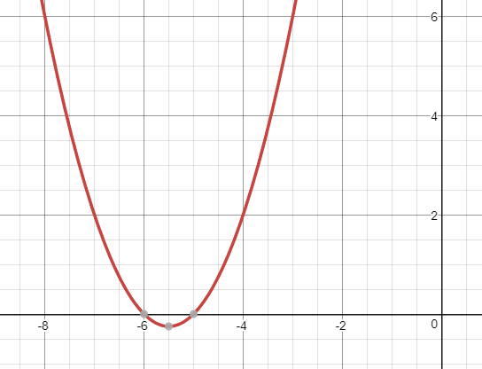
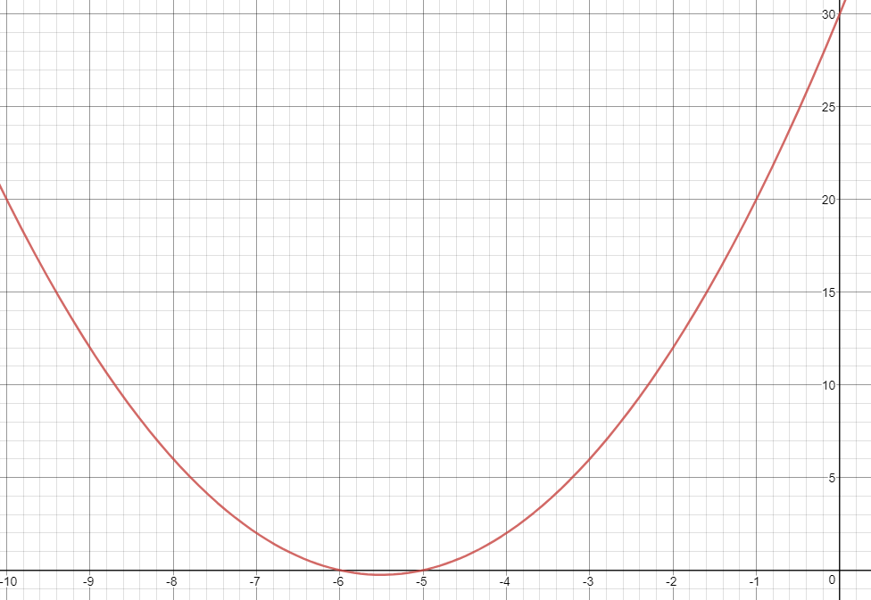

Classwork/homework: After finishing the notes, complete the ten problems on the reverse of this page.
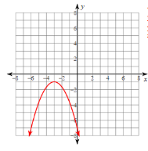
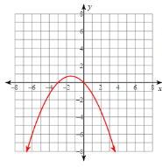
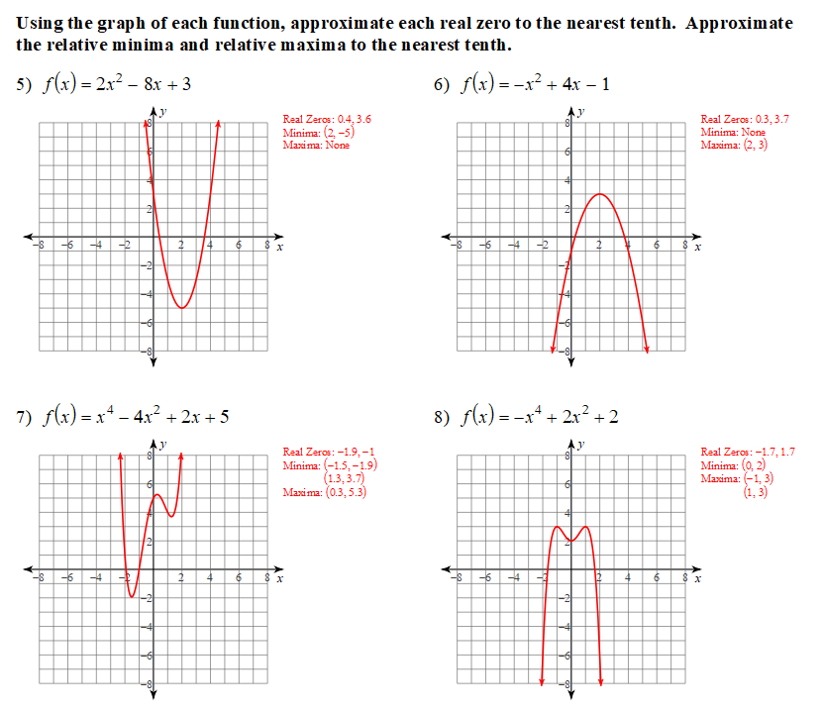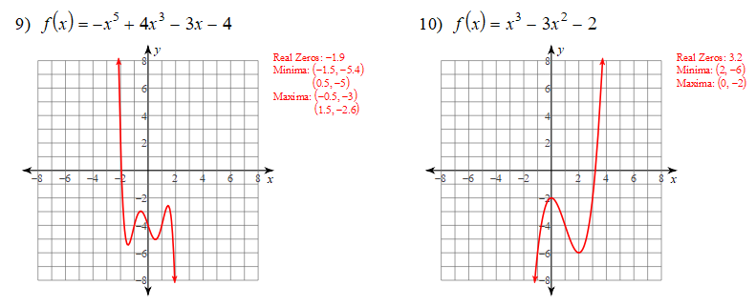

https://www.khanacademy.org/math/algebra/quadratics/features-of-quadratic-functions/v/finding-features-of-quadratic-functions

