Algebra II Notes 9/6-7/18
Function Notation and Function Addition

Warm-up:
Jorge invests $75 in supplies for his dog washing service. He charges $15 to wash a dog.
- Write an equation to represent the relationship between Jorge’s profit, y, and the number of dogs he washes, x.
- Jorge uses tap water to wash dogs at his business. Tap water costs $0.004 per gallon in Jorge’s town, and Jorge uses 6 gallons for each dog he washes. Write an equation to represent the relationship between Jorge’s water bill and the number of dogs he washes.
- Update your equation for Jorge’s profit, taking into account his costs for water.

Discuss:
- What was tricky about the warm-up?
- What variable did your group choose to represent Jorge’s costs for water? Why?

A different way of writing functions: function notation
In the equation you wrote for the first part of the warm up, Jorge’s profit was a function of the number of dogs he washed.
- What does this mean?

In function notation, we write functions explicitly in terms of their dependent variables.
- What variable would you like to use for “function?”
Ms. Burchfield will re-write the answer to (a) in function notation.
- What variable would you like to use for the function in part (b)?
Always remember to define your variables!

Adding and subtracting functions:
- What did your group do with parts (a) and (b) to answer part (c) of the warm-up?
- What is a good way of writing what you did in formal function notation?

- Try the following problems:
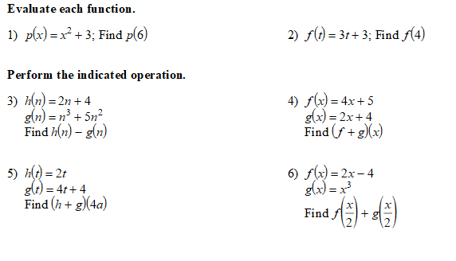
7) Given this graph of the function f(x):
f(x)
y
x
5
5
-5
-5

Find:
a. f(–4) b. f(0) c. x when f(x) = -2 d. x when f(x) = 0

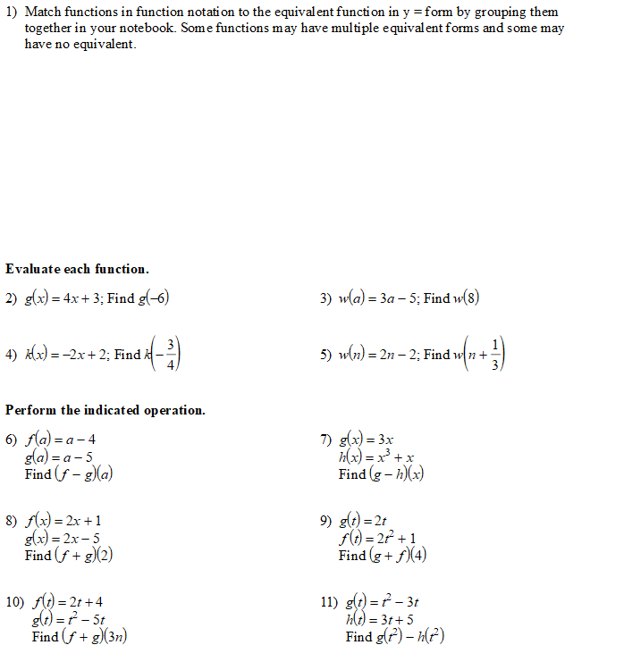
Homework on Function Notation and Addition of Functions (complete in notebook!)

$$f\left(x\right)=2x-3$$ | $$y=x^{3}$$
$$g\left(x\right)=x^{2}$$ | $$y=x^{2}$$
$$f\left(z\right)=\frac{z}{2}+\frac{7}{2}$$ | $$y=2x-3$$
$$P\left(x\right)=\frac{x}{2}+\frac{7}{2}$$ | $$y=2\sqrt{x}-x$$
$$f\left(x\right)=2\sqrt{x}-x$$ | $$y=\frac{x}{2}+\frac{7}{2}$$

- Swine flu is attacking Porkopolis. The function below determines how many people have swine where t = time in days and S = the number of people in thousands.
  - Find S(4).
  - What does S(4) mean?
  - Find t when S(t) = 23.
  - What does S(t) = 23 mean?
  - Graph the function

