Algebra II Notes 9/10-11/18
Multiplying and Dividing Functions in Function Notation
Warm-up: Simplify the following expressions:
- 3x(2x + 1) b. (4x + 3)(3x – 2)

Discuss:
- What was tricky about the warm-up?
- What happens when you multiply x times x? What if you multiply x times x times x?

Pause for… Homework Review!
Answers to yesterday’s homework (Questions? We’ll go over two or three of these!)
$1) f\left(x\right)=2x-3$ and $y=2x-3$
$g\left(x\right)=x^{2}$ and $y=x^{2}$
$f\left(z\right)=\frac{z}{2}+\frac{7}{2}$ and $y=\frac{x}{2}+\frac{7}{2}$ and $P\left(x\right)=\frac{x}{2}+\frac{7}{2}$
$f\left(x\right)=2\sqrt{x}-x$ and $y=2\sqrt{x}-x$
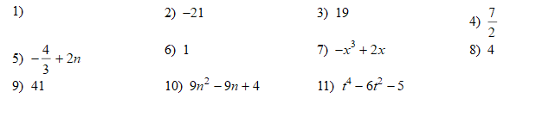
12) S(t) = 9t – 4
a. S(4) = 32 b. after 4 days, 32,000 people have swine flu. c. S(t) = 23 when t = 3. d. 23,000 people have swine flu after 3 days. e. see graph.

Yesterday we added and subtracted functions in function notation.
- What TWO different ways can we write addition of functions?

Today we will multiply and divide functions in function notation.
- What TWO different ways might you write multiplication of functions?

- Start the homework.

- Exit ticket: write ONE question you still have from last night’s homework. If none, write one question you have not yet solved from tonight’s homework.
Homework on Multiplying and Dividing Functions (Complete in Notebook)
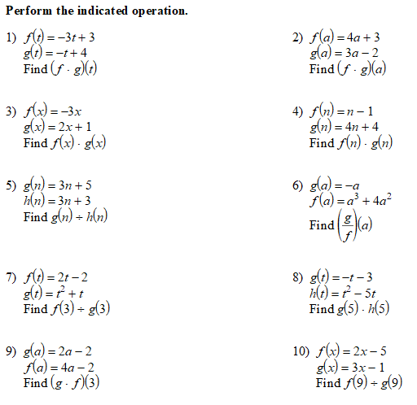

- Swine flu is attacking Porkopolis. The function below determines how many people have swine where t = time in days and S = the number of people in thousands.
  - Find S(4).
  - What does S(4) mean?
  - Find t when S(t) = 23.
  - What does S(t) = 23 mean?
  - Graph the function

