Algebra II Notes 9/12/18
Composition of Functions
Warm-up: Choose ONE of the problems on the reverse of this page and answer that question. Show your work!

Pause for… Homework Review
Answers to multiplication and division problems (you may not have done these yet—don’t panic)
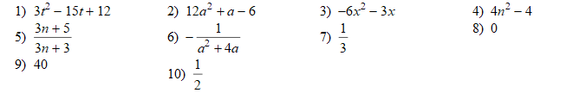
Composition combines two different functions by applying one first, then the other. This means the range (output) of the first function becomes the domain (input) of the second function.
- What notation could you use to for composition? That is, how could you show that you are substituting the output of one function, say, f(x), into another function, say, g(x)?
Just like with addition, subtraction, multiplication, and division, there are actually TWO notations for compositions. Below is a table of the notation we have studied to date. Some cells are incomplete; fill those in for yourself (Ms. Burchfield will go over some).
Operation | Function Notation | Function Addition | Function Subtraction | Function Multiplication | Composition of Functions
Notation | Given f(x), find f(a) | Given f(x) and g(x), find  (f + g)(x) |  | Given f(x) and g(x), find (f · g)(x) | Given f(x) and g(x), find (f(g(x))
Alternate  Notation |  | Find f(x) + g(x) |  | Find f(x) · g(x)
How to: | Substitute x = a | Substitute the rules for both functions |  | Substitute the rules for both functions | Substitute x = (the rule for the second function) into the first function
Don’t forget to: |  |  | Distribute! | Distribute! | Use parentheses!
- On the next page are several practice problems. Start these as review! They are classwork. Ms. Burchfield will check notebooks—and check in on methods—while you work.
Closure: composition is a formal way of writing what you’ve already done. Here’s a problem from the weekend’s homework:
What did you do to solve the problem?
Adding one third to a variable is, itself, a function. Let’s call that f(n). f(n) = n + 1/3
This makes the old homework problem a composition. Rewrite the question using f(n).
Classwork on Composing Functions (Practice for quiz—check your answers!)
