Algebra II Classwork/Homework Name: _________________
Discriminant Date: __________________
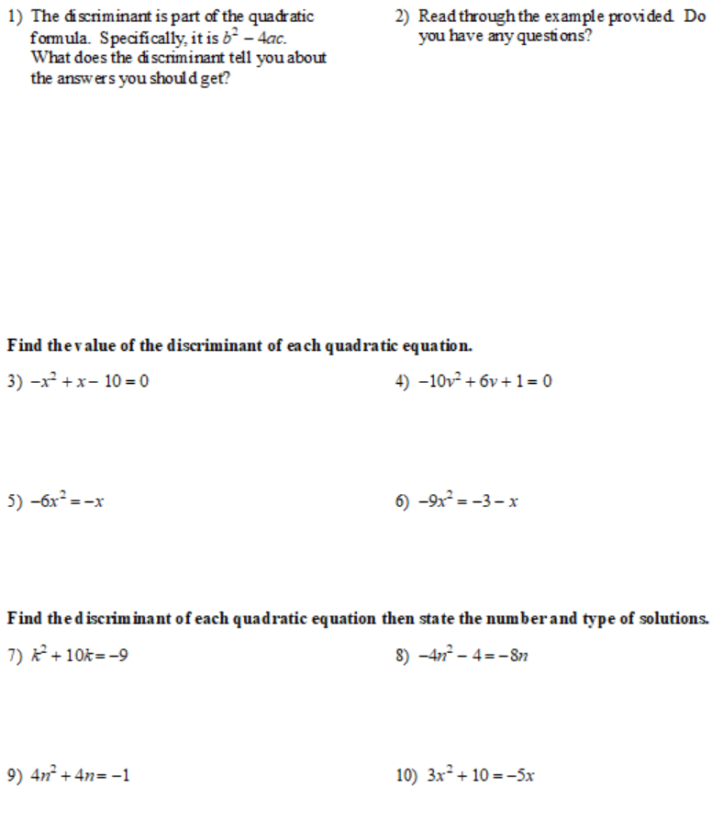

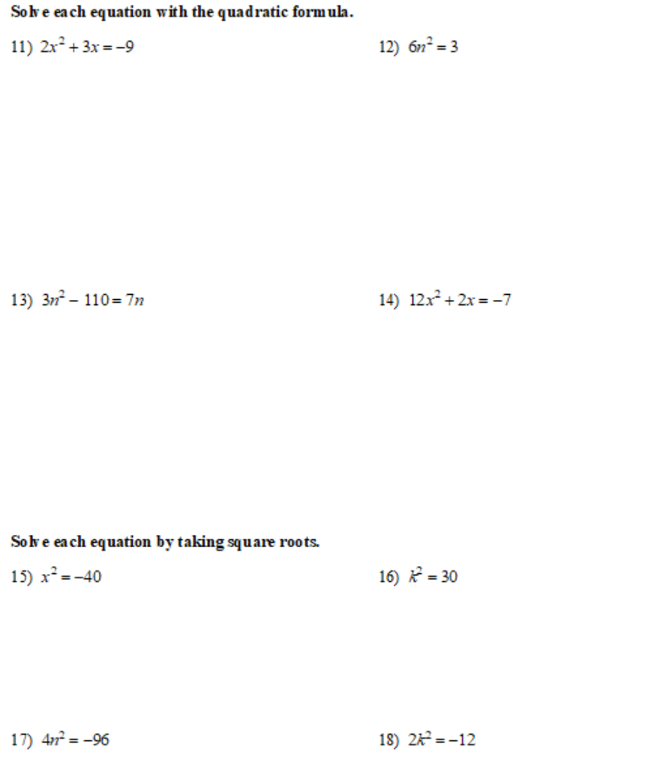

https://www.khanacademy.org/math/algebra/quadratics/solving-quadratics-using-the-quadratic-formula/a/discriminant-review

